**PIZZA SALES SQL QUERIES**

1. **KPI’s**
2. **Total Revenue:**

SELECT SUM(total_price) AS Total_Revenue FROM pizza_sales



1. **Average Order Value:**

SELECT SUM(total_price) / COUNT(DISTINCT order_id) AS Avg_Order_Value FROM pizza_sales



1. **Total Pizza Sold:**

SELECT SUM(quantity) AS Total_Pizza_Sold FROM pizza_sales



1. **Total orders:**

SELECT COUNT(DISTINCT order_id) AS Total_Orders FROM pizza_sales



1. **Average Pizzas per Order**

SELECT CAST(CAST(SUM(quantity) AS DECIMAL(10, 2)) /

CAST(COUNT(DISTINCT order_id) AS DECIMAL(10, 2)) AS DECIMAL(10, 2)) AS Avg_Pizzas_Per_Order FROM pizza_sales



**GRAPHS**

1. **Daily Trend**

SELECT DATENAME(DW, order_date) AS Order_Day, COUNT(DISTINCT order_id) AS Total_Orders

from pizza_sales

GROUP BY DATENAME(DW, order_date)

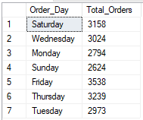

1. **Hourly Trend**

SELECT DATEPART(HOUR, order_time) AS Order_Hours, COUNT(DISTINCT order_id) AS Total_Orders

from pizza_sales

GROUP BY DATEPART(HOUR, order_time)

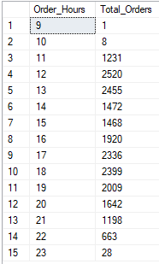

1. **Pct of Sales by Category**

SELECT pizza_category, SUM(total_price) AS Total_Sales, SUM(total_price) * 100 /

(SELECT SUM(total_price) FROM pizza_sales WHERE MONTH(order_date) = 1) AS PCT

FROM pizza_sales

WHERE MONTH(order_date) = 1

GROUP BY pizza_category

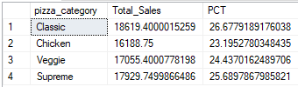

1. **Percentage of Sales by Pizza Size**

SELECT pizza_size, CAST(SUM(total_price) AS DECIMAL(10, 2)) AS Total_Sales, CAST(SUM(total_price) * 100 /

(SELECT SUM(total_price) FROM pizza_sales WHERE DATEPART(QUARTER, order_date)=1) AS DECIMAL(10, 2)) AS PCT

FROM pizza_sales

WHERE DATEPART(QUARTER, order_date)=1

GROUP BY pizza_size

ORDER BY PCT DESC

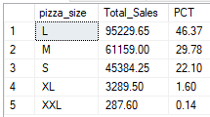

1. **Total Pizza Sold by Category**

SELECT pizza_category, SUM(quantity) AS Total_Pizzas_Sold

FROM pizza_sales

GROUP BY pizza_category

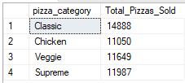

1. **Top 5 Best Seller Pizzas**

SELECT TOP 5 pizza_name, SUM(quantity) as Total_Pizzas_Sold

from pizza_sales

GROUP BY pizza_name

ORDER BY SUM(quantity) DESC

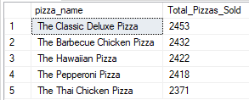

1. **Bottom 5 Worst Seller Pizzas**

SELECT TOP 5 pizza_name, SUM(quantity) as Total_Pizzas_Sold

from pizza_sales

WHERE MONTH(order_date)=1

GROUP BY pizza_name

ORDER BY SUM(quantity) ASC

